Sprint [2] UI Prototypes

US002: As a condo management company, I want to create a profile for each property under my management, specifying details such as property name, unit count, parking count, locker count, and address.

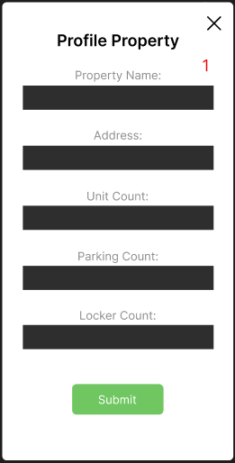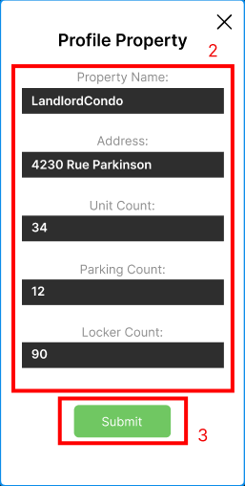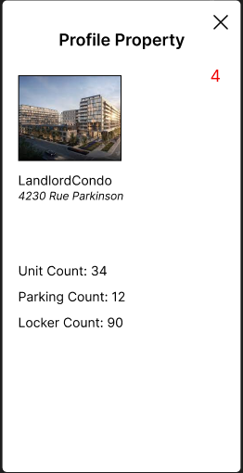  
 Landing Page Property Submission Property Page

Steps:

1. The user accesses the profile property landing page.
2. The user fills in the form data for the property, error messages occur if items are missing, or the wrong data type is input.
3. The user submits the property, that’s reviewed and submitted.
4. New profile property page is created.

US004: As a condo management company, I want to enter detailed information for each condo unit, parking spot, and locker, including unit id,

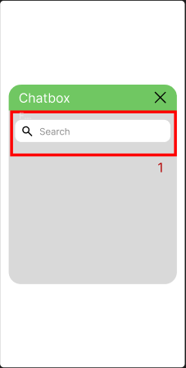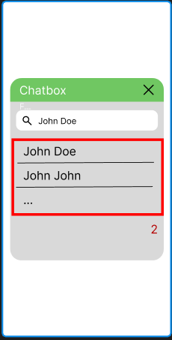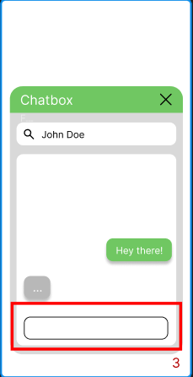 Chatbox Landing Page Searching Chatbox Texting

Steps:

1. User is on the landing page, and searches for a contact.
2. User chooses contact based on search results.
3. User texts messages, and interacts with contact.